SUBSCRIBERS GALORE : EXPLORING WORLD’S TOP YOUTUBE CHANNEL

# 1.INDRODUCTION:

* 1. OVERVIEW :

A subscriber to a channel on the video-sharing YouTube is a user who has chosen to receive the channel's content by clicking on that channel's "Subscribe" button, and each user's subscription feed consists of videos published by channels to which the user is subscribed. The ability to subscribe to users was introduced in October 2005. YouTube began publishing a list of its most- subscribed channels in April 2006. An early archive of the list dates to May 2006.

* 1. PURPOSE :

YouTube subscribers refer to the people or accounts that are subscribed to your channel.so whenever you upload a new video , your subscribers will be able to see it in where feeds.

# 2.PROBLEM STATEMENT AND DESIGN THINKING:

Problem Understanding, also known as Problem Definition or Problem Identification, is the initial and critical phase of any data analysis or problem-solving process. It involves gaining a clear and comprehensive understanding of the problem at hand, its context, scope, and objectives.

# 2.1. EMPATHY MAP :

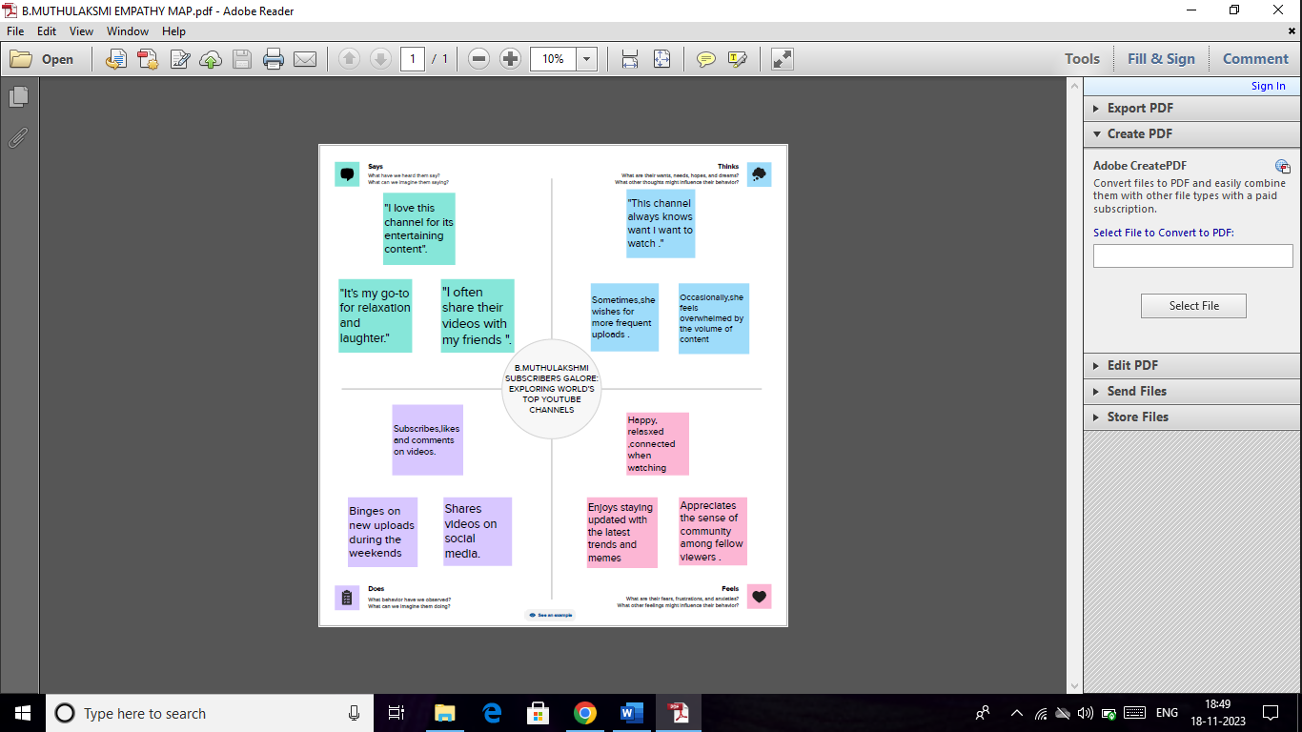

# 2.2. IDEATION AND BRAINSTORMING MAP:

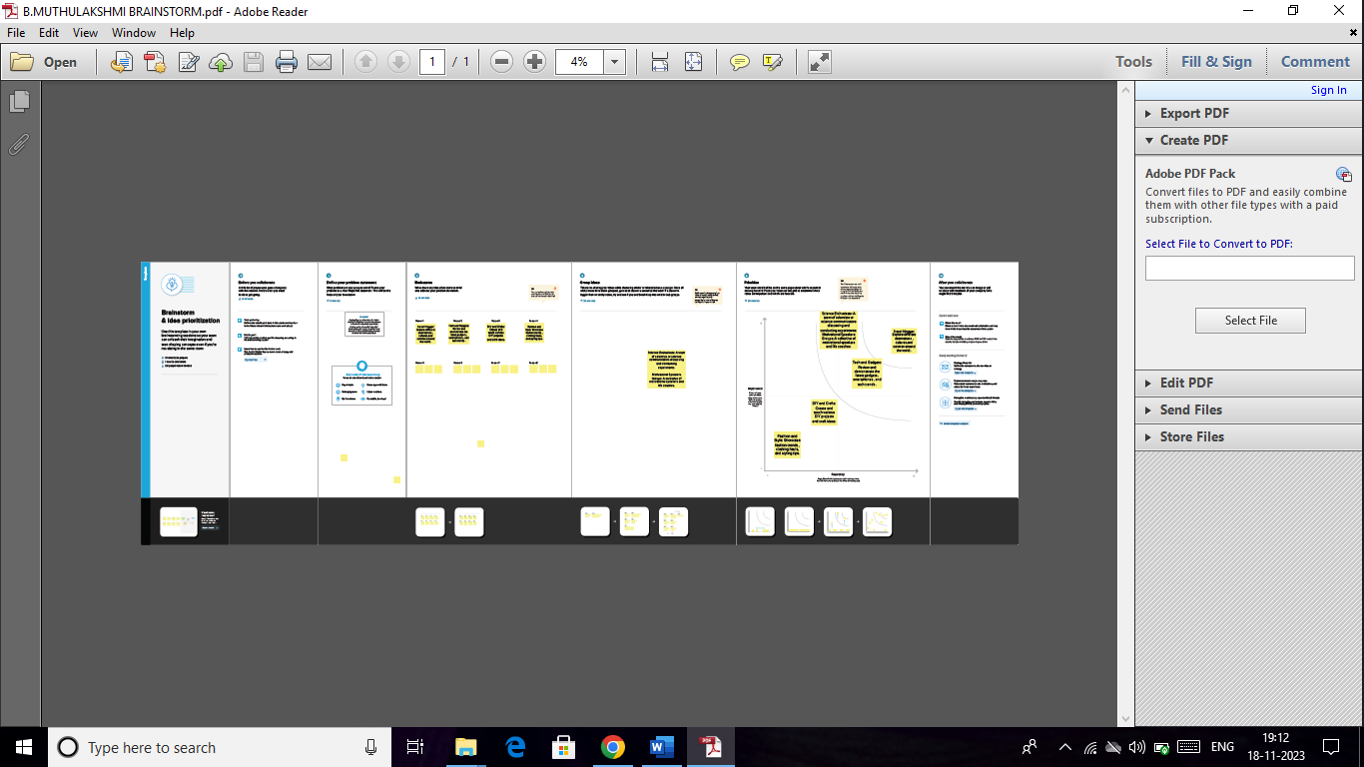

# 3.RESULT:

### Dashboards :

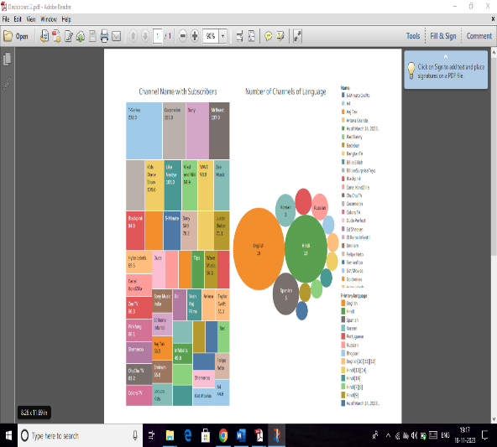 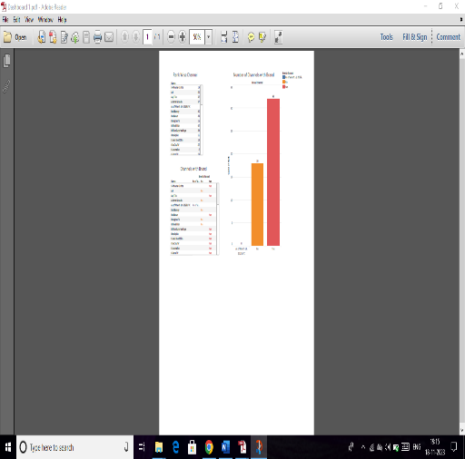

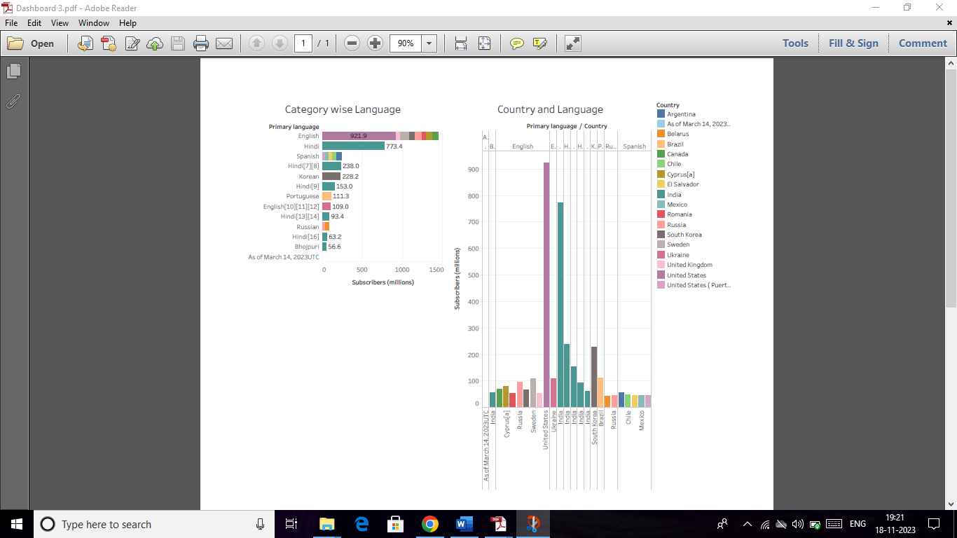 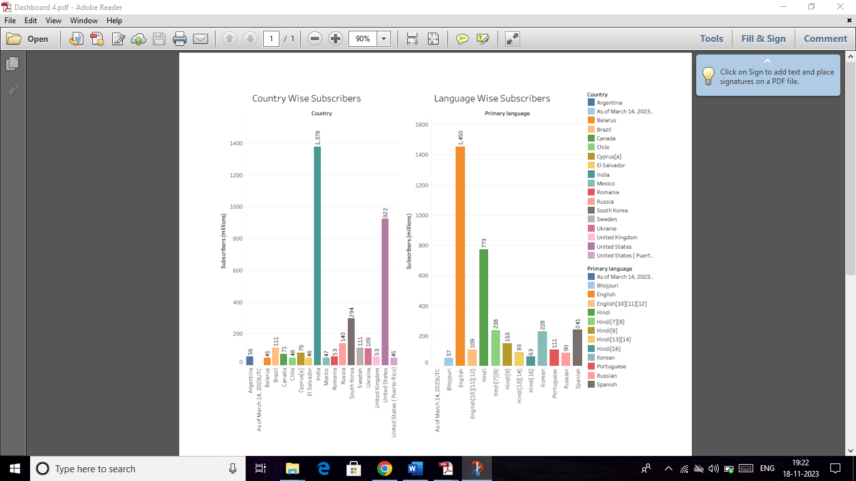

STORY:

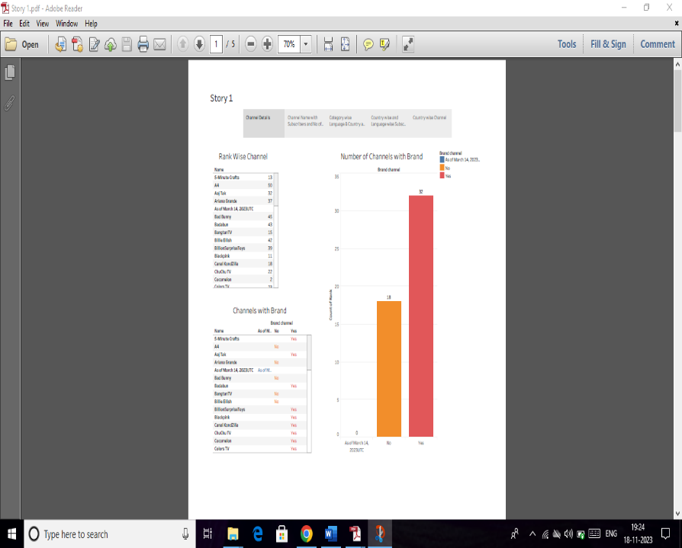

# 4. ADVANTAGE AND DISADVANTAGE:

# Advantage:

* You‘re your own boss.
* As a youtuber , you have creative control over your content.
* You decide your hours and weather to work from home or get an office space.

# Disadvantage:

* Distracting or harmful content…
* Quality or accuracy issues.
* No control over link permanence.

# 5. APPLICATIONS:

Indian record label T-Series is the most subscribed channel, with over 252 million subscribers has of November 2023.

# 6. CONCLUSION:

That qualifies them to get a split of the ad revenue that comes from their videos.

# 7. FUTURE SCOPE:

Increased diversification of content :

YouTube may see a broader range of content catering to more niche audiences. This trend has been on going , with the rise of specialized channels focusing on specific topics , hobbies , and communities.